Q.1 Write the programme to open a text file named input 2, and copy its contents to an output text file output 2.
CODE:
import java.io.*;

public class FileCopy {
public static void main(String[] args) {
// Names of the input and output files
String inputFileName = "input2.txt";
String outputFileName = "output2.txt";

// Use try-with-resources to ensure streams are closed after use
try (BufferedReader reader = new BufferedReader(new FileReader(inputFileName));
BufferedWriter writer = new BufferedWriter(new FileWriter(outputFileName))) {

String line;
// Read each line from the input file and write it to the output file
while ((line = reader.readLine()) != null) {
writer.write(line);
writer.newLine(); // Write a newline character after each line
}

System.out.println("File copied successfully.");
} catch (IOException e) {
e.printStackTrace();
}
}
}
OUTPUT:
Q.2 Write the programme to show multithreading for the string “multi threads”. Show the resulting output.
CODE:
public class MultiThreadingExample {
public static void main(String[] args) {
String text = "multi threads";

// Create an array to hold the threads
Thread[] threads = new Thread[text.length()];

// Loop through each character in the string
for (int i = 0; i < text.length(); i++) {
final int index = i;
threads[i] = new Thread(() -> {
System.out.print(text.charAt(index) + " ");
});
// Start each thread
threads[i].start();
}

// Wait for all threads to finish
for (Thread thread : threads) {
try {
thread.join();
} catch (InterruptedException e) {
e.printStackTrace();
}
}

System.out.println("\nAll threads have finished execution.");
}
}

OUTPUT:
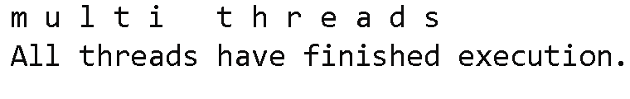
Q.3 Implement a Java program that creates a thread using the Runnable interface. The thread should print numbers from 1 to 10 with a delay of 1 second between each number.
CODE:
public class NumberPrinter implements Runnable {
@Override
public void run() {
try {
for (int i = 1; i <= 10; i++) {
System.out.println(i);
Thread.sleep(1000); // Sleep for 1 second
}
} catch (InterruptedException e) {
System.out.println("Thread was interrupted.");
}
}

public static void main(String[] args) {
// Create an instance of the NumberPrinter
NumberPrinter numberPrinter = new NumberPrinter();

// Create a Thread object and pass the Runnable instance
Thread thread = new Thread(numberPrinter);

// Start the thread
thread.start();
}
}

OUTPUT:
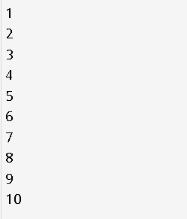

Q.4 Write a Java program that creates and starts three threads. Each thread should print its name and count from 1 to 5 with a delay of 500 milliseconds between each count.
CODE:
class CounterThread implements Runnable {
private String threadName;

public CounterThread(String threadName) {
this.threadName = threadName;
}

@Override
public void run() {
try {
for (int i = 1; i <= 5; i++) {
System.out.println(threadName + ": " + i);
Thread.sleep(500); // Sleep for 500 milliseconds
}
} catch (InterruptedException e) {
System.out.println(threadName + " was interrupted.");
}
}

public static void main(String[] args) {
// Create instances of CounterThread
CounterThread thread1 = new CounterThread("Thread 1");
CounterThread thread2 = new CounterThread("Thread 2");
CounterThread thread3 = new CounterThread("Thread 3");

// Create Thread objects and pass the Runnable instances
Thread t1 = new Thread(thread1);
Thread t2 = new Thread(thread2);
Thread t3 = new Thread(thread3);

// Start the threads
t1.start();
t2.start();
t3.start();
}
}
OUTPUT:

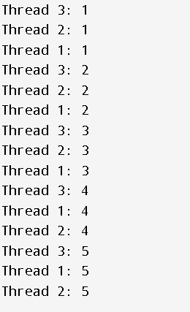

Q.5 Create a Java program that demonstrates thread priorities. Create three threads with different priorities and observe the order in which they execute.
CODE:
class PriorityThread extends Thread {
public PriorityThread(String name) {
super(name);
}

@Override
public void run() {
for (int i = 1; i <= 5; i++) {
System.out.println(getName() + ": " + i);
try {
Thread.sleep(200); // Sleep for 200 milliseconds
} catch (InterruptedException e) {
System.out.println(getName() + " was interrupted.");
}
}
}

public static void main(String[] args) {
// Create three threads with different priorities
PriorityThread highPriorityThread = new PriorityThread("High Priority Thread");
PriorityThread mediumPriorityThread = new PriorityThread("Medium Priority Thread");
PriorityThread lowPriorityThread = new PriorityThread("Low Priority Thread");

// Set the priorities
highPriorityThread.setPriority(Thread.MAX_PRIORITY); // Maximum priority (10)
mediumPriorityThread.setPriority(Thread.NORM_PRIORITY); // Normal priority (5)
lowPriorityThread.setPriority(Thread.MIN_PRIORITY); // Minimum priority (1)

// Start the threads
lowPriorityThread.start();
mediumPriorityThread.start();
highPriorityThread.start();
}
}
OUTPUT:
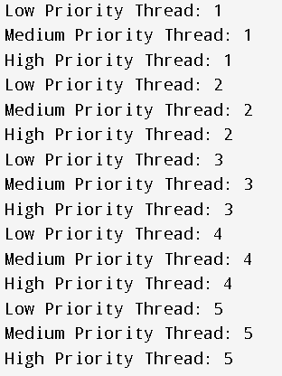

Q.6 Write a Java program that creates a deadlock scenario with two threads and two resources.
CODE:
public class DeadlockExample {
public static void main(String[] args) {
final Object resource1 = "Resource 1";
final Object resource2 = "Resource 2";

// Thread 1 tries to lock resource1 then resource2
Thread thread1 = new Thread(() -> {
synchronized (resource1) {
System.out.println("Thread 1: locked resource 1");

// Adding delay so that Thread 2 can lock resource2
try { Thread.sleep(50); } catch (InterruptedException e) {}

synchronized (resource2) {
System.out.println("Thread 1: locked resource 2");
}
}
});

// Thread 2 tries to lock resource2 then resource1
Thread thread2 = new Thread(() -> {
synchronized (resource2) {
System.out.println("Thread 2: locked resource 2");

// Adding delay so that Thread 1 can lock resource1
try { Thread.sleep(50); } catch (InterruptedException e) {}

synchronized (resource1) {
System.out.println("Thread 2: locked resource 1");
}
}
});

// Start both threads
thread1.start();
thread2.start();
}
}
OUTPUT:
